From: https://thesaker.is/how-my-book-unmasking-bill-browder-was-censored-by-amazon-by-alex-krainer/

How my book unmasking Bill Browder was censored by Amazon by Alex Krainer
40303 ViewsOctober 05, 2017 86 Comments
[Note by the Saker: for my review of Alex Krainer’s book please click here]

“I always say the truth is best even when we find it unpleasant. Any rat in a sewer can lie. It’s how rats are. It’s what makes them rats. But a human doesn’t run and hide in dark places, because he’s something more. Lying is the most personal act of cowardice there is.” ― Nancy Farmer, “The House of the Scorpion”
In January 2015 I received a book titled “Red Notice” written by Bill Browder, once a hedge fund manager running Hermitage Capital the largest foreign-owned hedge fund in Russia. In the past, my path had crossed with Browder’s on two occasions. In 2005, I was invited to his presentation, only days before he was expelled from Russia. On that occasion Browder surprised me because he was the first credible person I ever heard speaking positively about Vladimir Putin. The next time I met Browder was in 2010 during an investment conference in Monaco. This time he was very anti-Putin. When I received his book, it was recommended to me as an excellent read.
Through his book, Browder presents himself in glowing colors. By contrast, he portrays Russia as a sinister, backward tyranny and President Putin as the greediest, most ruthless tyrant since Genghis Khan. The book’s main plot shapes up as an appealing story about the struggle of good against evil, about a lone maverick (Browder himself), taking on a powerful network of dangerous criminals and corrupt government officials in selfless pursuit of justice. It would be a beautiful story – if only it were true.
I was familiar with Parts of Browder’s story, so his tale seemed fishy to me. A few days after reading it I had to re-read it from the beginning. Sure enough, I discovered quite a number of things that didn’t add up which prompted me to do some research of my own. Much about it bothered me enough that I ended up writing a whole book which I titled “The Killing of William Browder: Deconstructing Bill Browder’s Dangerous Deception.” In August of this year I finally finished it and self-published it on Amazon.com.
My book’s main object is to unmask Browder’s brazen and dangerous deception. Beyond this, I’ve also sought to put his story into proper context by including a rather detailed account of the relevant events that led to the collapse of the USSR, Russia’s subsequent transition from Communism to Capitalism and what 17 years of Vladimir Putin’s leadership have changed. I’ve also included a section discussing the person and character of Vladimir Putin (since Browder relentlessly demonizes him). The book’s last chapter discusses the history of the relations between the U.S. and Russia from the beginnings of the 19th century, including the U.S. Civil War when Russia came to Abraham Lincoln’s aid and played the key role in preserving the Union and what the future relations between the U.S. and Russia might, or should be.
As it turned out, my book was surprisingly well received by its readers and during the first few weeks it received very encouraging reader reviews (seven five-star and one four-star review). Unfortunately, by mid-September “The Killing of William Browder” came up on Browder team’s radar and my problems began. It seems that in the free world, the freedom of expression comes with some restrictions. Exposing Bill Browder is one of them.
On 13th September, University of Tulsa professor Jeremy Kuzmarov cited some of the materials from my book in his own Hffington Post article about Bill Browder, titled “Raising the Curtain on the Browder-Magnitsky Story.” I was flattered by that article, but Huffington Post scrubbed it from their website within hours. A week later, Amazon’s publishing company, CreateSpace “suppressed” my book, purging it from Amazon.com website and from its Kindle store.
CreateSpace explained that a third party claimed that my book “may contain defamatory content,” and that to resolve the issues I needed to contact Mr. Jonathan M. Winer, Mr. Browder’s legal counsel. Mr. Winer’s word was all that was necessary for Amazon to oblige and remove my book from its bookstore. My protest and subsequent communications with CreateSpace had no effect and my only venue was to “work” with Browder’s lawyers to “resolve the issues.” In other words, I was put in the situation to have Browder censor my book and decide on whether it could be published or not. At first I rejected idea and refused to contact Mr. Winer offering instead my book for free to whoever requested a copy. But subsequently I decided to write to Mr. Winer anyway to find out what, if anything went wrong. So far, I have received no response.
This is not the first time Bill Browder – and whoever is backing him – has effectively censored what the Western public may or may not know about his story. In 2016, Russian film-maker Andrei Nekrasov made the documentary film, “The Magnitsky Act – Behind the Scenes.”
Over the years, Nekrasov had built a reputation for producing documentaries that were critical of the Russian government, and with the Magnitsky affair, he initially followed Browder’s narrative of the events and even envisioned Browder as the film’s narrator. But his research into the subject turned up a number of problems with Browder’s story. Nekrasov reached out to him for an explanation, but was unable to get in touch with Browder for several months. Nekrasov finally tracked down Browder at a book signing event where he tried and failed to get clarifications from him. Ultimately however, Nekrasov managed to meet with Browder and with the cameras rolling, he began to lay out his findings. As he did so, Browder became visibly vexed until at one moment he abruptly interrupted Nekrasov with an accusation that he was spreading Russian propaganda.
When Nekrasov’s film was completed, Browder took aggressive action to block its screenings. With threats of lawsuits, he prevented an already scheduled screening to a group of Members of the European Parliament in Brussels. He did the same with another screening in Norway, and even managed to pressure the Franco-German television network “Arte” to call off the showing of Nekrasov’s film on its channel. In June 2016, Browder tried to force The Newseum in Washington DC to cancel the screening of Nekrasov’s film. Thankfully, The Newseum, whose laudable mission is to promote freedom of expression and “the five freedoms of the First Amendment to the U.S. Consitution,” refused to be cowed by Browder’s intimidation and showed the film to a Washington audience.
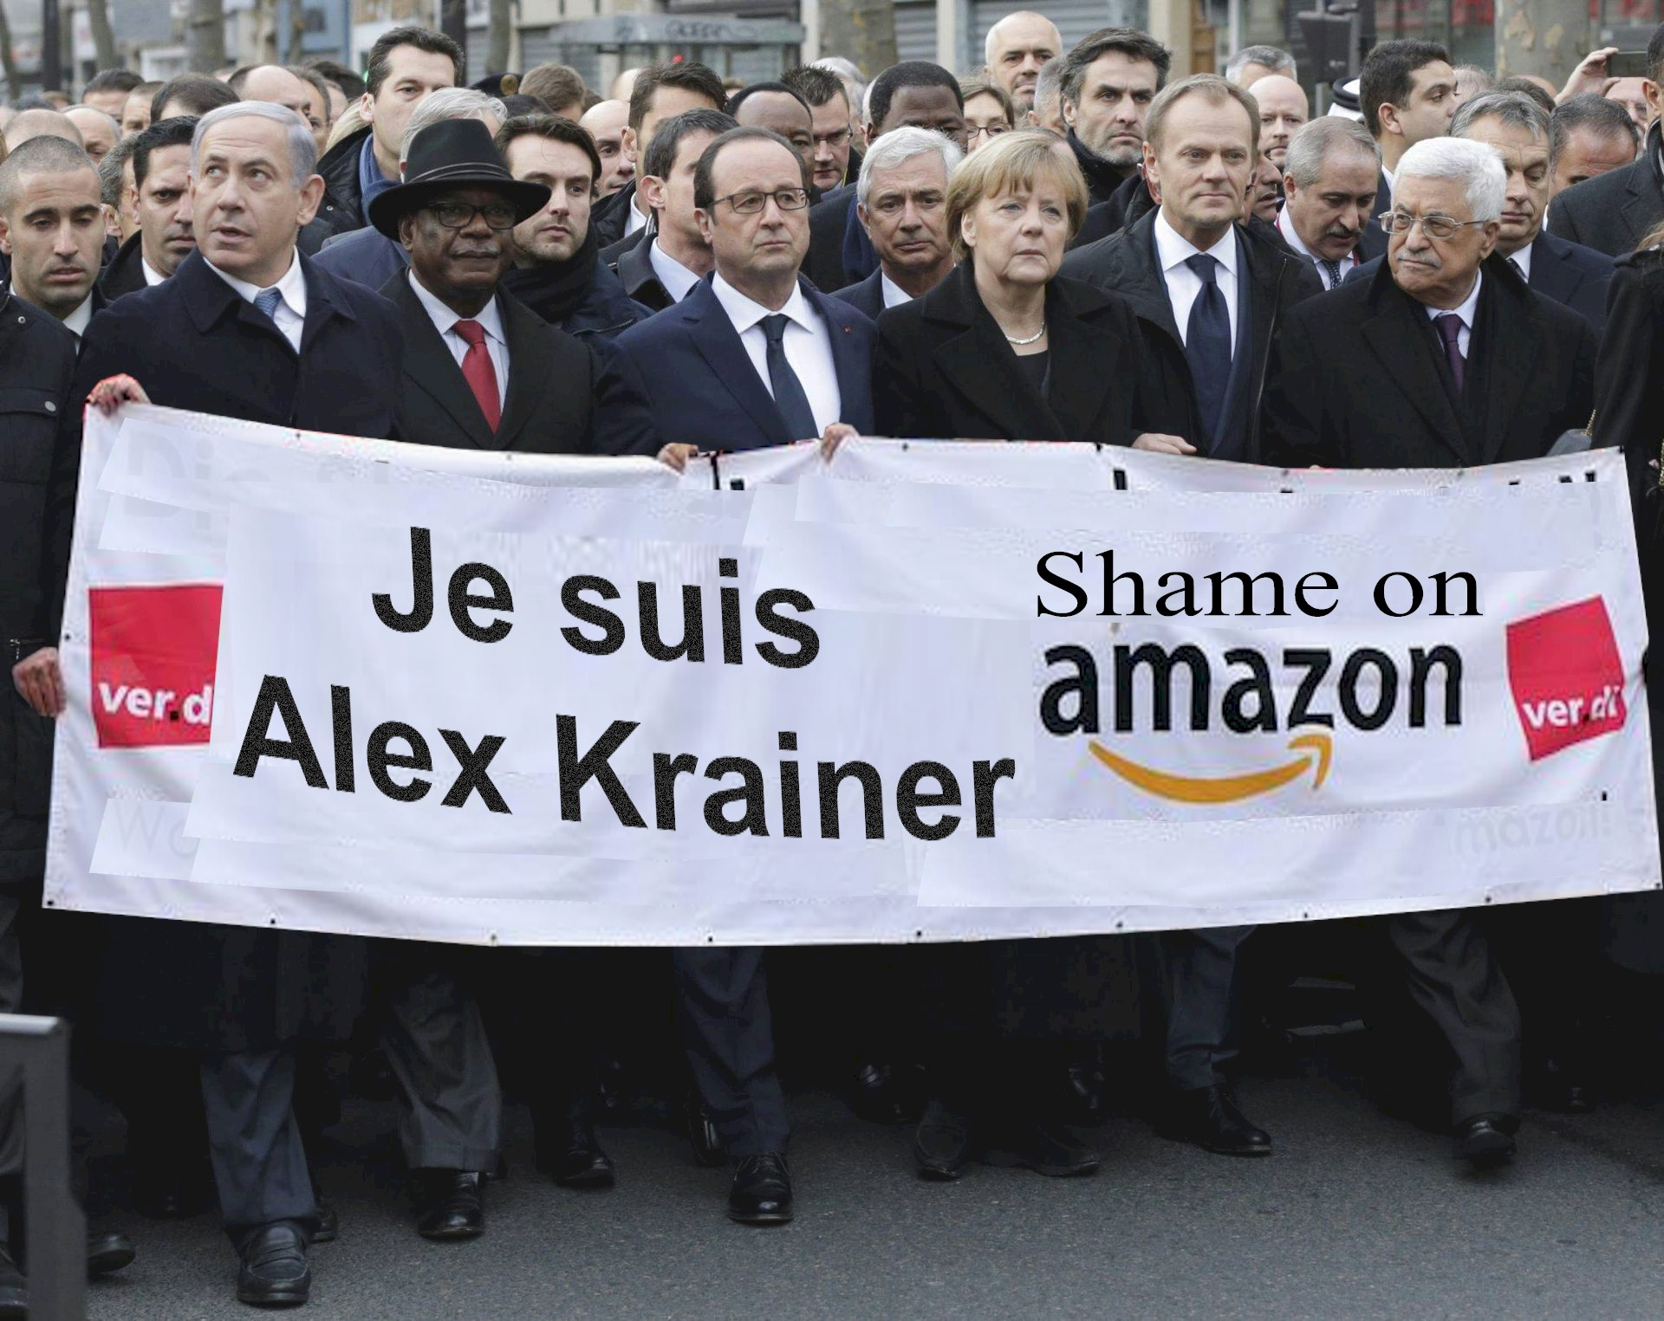
No, unfortunately this did not happen. Freedom of expression – which should be sacrosanct – is dangerously compromised in the west.
Open, civilized societies seek resolution of contentious issues by allowing proponents of different sides in any dispute to present their respective points of view. An informed, open debate is by far the best mechanism of conflict resolution because we can only arrive at constructive solutions to problems by taking different stakeholders’ points of view into consideration. Browder’s approach is contrary to that of civilized societies: he seeks to silence all points of view but his own. He seeks to persuade not by initiating an informed debate, but by suppressing all debate. This is not the conduct of a truth teller pursuing elevated objectives like human rights, justice, and truth. Truth does not need such forceful defense. As Oliver Wendell Holmes wrote, “Truth is tough. It will not break, like a bubble, at a touch. Nay, you may kick it about all day, and it will be round and full at evening.” Browder is clearly anxious that his story cannot take any kicking at all. Meanwhile in the western world, we appear to be at the mercy of lawyered-up elites for what we are allowed to know and what we are not.
In the end, I have no doubt that truth will prevail and that Bill Browder will lose his battle to keep his deception going. It is because there’s something sacrosanct about truth and most people will reject a lie once they are aware of it.
Alex Krainer is a hedge fund manager based in Monaco. His book, “The Killing of William Browder” may still be available in paperback at Book Depository, Barnes&Noble (USA), Amazon.fr, Amazon.co.uk, or Amazon.de

